India: Recent Economic Developments and Outlook

# GDP growth in 2019 picked up

GDP growth picked up by 4.2% year-on-year (yoy) in 2019. On the demand side, private consumption (60.3% of GDP) contributed the most to growth, with 3.1 percentage points (pp). On the supply side, services (49.4% of GDP) contributed the most to growth, with 2.7pp.

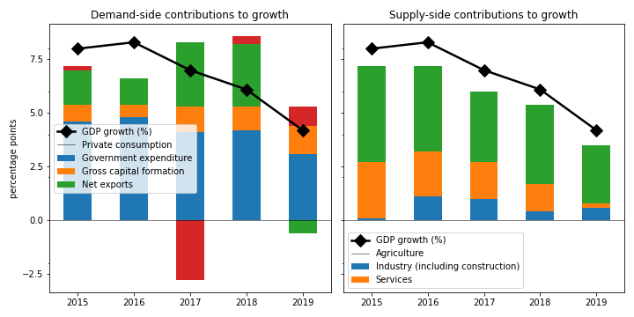

## Government expenditure picked up the fastest on the demand side

Government expenditure picked up by the largest margin (11.8%). Private consumption picked up by 5.3%. On the other hand, gross capital formation decreased by 2.0%. On the other hand, net exports declined by 22.2%.

## On the supply side, services grew the fastest

Services grew the most rapidly (5.5%). Agriculture picked up by 4.0%. Industry (including construction) grew by 0.9%.

## Unemployment declined; inflation increased

Unemployment declined from 5.3% in 2018 to nan% in 2019, while inflation increased from 4.9% to 7.7%. At the end of 2020, the central bank set the policy rate at 4.0%.

## Current account balance deficit

The current account balance (CAB) recorded a deficit at 1.0% of GDP in 2019, compared to 2.4% in 2018.

USA is the top export destination (16.8% of exports in 2019). Other major exports partners include United Arab Emirates (9.1%), China (5.3%), and China, Hong Kong SAR (3.6%). Top export products are mineral fuels, mineral oils and products of their distillation; bituminous substances; mineral waxes (13.8% of exports).

Top imports origins are China (14.3%), USA (7.3%), United Arab Emirates (6.3%), and Saudi Arabia (5.6%). Major import commodities are mineral fuels, mineral oils and products of their distillation; bituminous substances; mineral waxes(31.9% of imports).

# Output contracted in Q3 2020

Output plunged by 7.5% yoy in Q3 2020 (-23.9% in the previous quarter). Government expenditures decreased by the largest margin at -22.5% yoy. Household consumption slowed down by 11.4%.

## Leading indicators

Industrial production shrank by 0.3% yoy in November (-10.6% yoy in October).

## Inflation decreased

Inflation stabilized to 2.9% yoy in January (4.5% yoy in December). Meanwhile, the central bank kept the policy rate to 4.0% in February.

# Outlook tilted downwards this year

As of January 2021, Consensus Economics panelists project economic growth ending at -8.0% in 2021, while in 2022, the panelists foresee growth at 10.3%. Over the same period, consumption is expected to change by -10.0% and 11.4%, while investment is projected to change by -15.7% and 15.2%. Industrial production is seen to change by -9.9% and 12.5%. Finally, Consensus Economics foresee inflation at 6.3% in 2021 and 4.7% in 2022.

*Sources: Consensus Economics, The World Bank, UN Comtrade, Haver Analytics, and National Sources. Accessed 06 February 2021.*